Statistical test

Attrition And DistanceFromHome

* 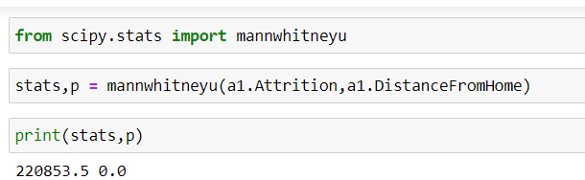 As the P value of 0.0 is < 0.05, the H0 is rejected and Ha is accepted.
* H0 -> There is no significant differences in the Distance From Home and Attrition

Ha -> There is a significant differences in the Distance From Home and Attrition

Attrition And TotalWorkingYears

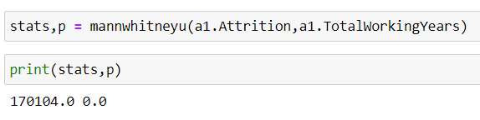---

* As the P value of 0.0 is < 0.05, the H0 is rejected and Ha is accepted.
* H0 -> There is no significant differences in the TotalWorkingYears and Attrition
* Ha -> There is a significant differences in the TotalWorkingYears and Attrition

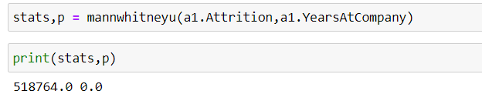 As the P value of 0.0 is < 0.05, the H0 is rejected and Ha is accepted.

H0 -> There is no significant differences in the YearsAtCompany and Attrition

Ha -> There is a significant differences in the YearsAtCompany and Attrition

Attrition vs YearsWithCurrentManager

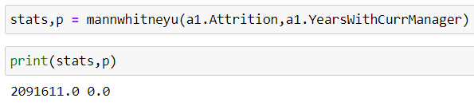

* As the P value of 0.0 is < 0.05, the H0 is rejected and Ha is accepted.
* H0 -> There is no significant differences in the YearsWithCurrManager and Attrition
* Ha -> There is a significant differences in the YearsWithCurrManager and Attrition